**HDL Concepts:**

**ANS:1)**

No,Both are different.Y1 adds all 4 together.While Y2 first adds A,B then C,D & finally adds the result of A+B & C+D.

**ANS:2)**

Boththe modules have the same function as we have used non blocking statements.In first case both x & y will get the value at same instant of time.The value of x in the expression of y is the old one. Also in the 2nd module both x & y will get executed at same time. Here also the value of x in the expression of y is the old one.

**Part 2:<= replaced with =**

***a)***Now (e & f) will be calculated the value will be given to x.This new value of x Or ed

With c gives us the value of y.So now value of y depends on new value of x which depends on e,f. ***b)*** 1st value of x|c is calculated it is given to y.Then value of (e&f) is calculated.It is given to x. Here y is calc with old value of x.Then x gets a new value.

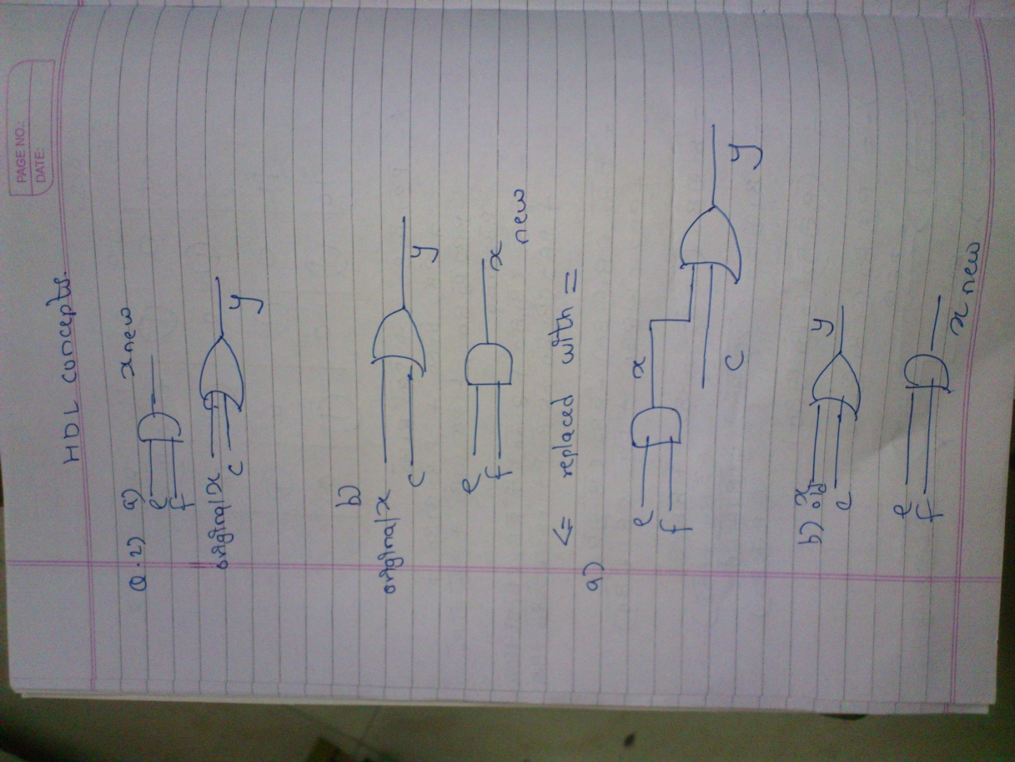

**ANS:3)**

**Corrected Errors:**

**a]** always@(a or b).Also the operators cannot be applied to entire array but to one element at a time.

**b]**

always@(posedge s,d0,d1)

begin

if(s==1’b1)

y=d1;

else y=d0;

end

endmodule

there was no need of nonblocking statement as at a time only one of if else is executed.

**d]**

**1.**sum depends on both a and b.

2.sum depends on both a and b.

3.sum depends on both a and b.